LC_Mare

Generate config.txt
The file config.txt is used to keep essential parameters during hibernation. It may also be used to generate a delayed start, to modify some meta data well before deployment. The file resides in the microSD card. If not present the software will use default values for all parameters that are hard coded during compilation.
The easiest way to generate a proper formatted config.txt file is to insert a blank disk into the recorder, disconnect the batteries and connect to PC via USB. The program will start up and start recording. On connected Terminal program stop program execution by pressing “e”. By pressing “y1”+return, the program will generate a config.txt file and hibernates until the next full minute. Once the program has restarted, it can be stopped again with pressing “e”. The generated config.txt file can now be edited.
Example config.txt file
# configuration file
# should end with '#' or ';' comment may follow
#
!a 60 # file size (sec)
!o 2 # on time (min)
!r 0 # repetition interval (min)
!f 384 # sampling frequency (kHz)
!g 20 # analog gain (dB)
!s AS1 # (ISRC) source with sensitivity
!c WMXZ # (ICMS) commissioning organization
!n WMXZ # (IART) name of operator (creator)
!p microPAM # (IPRD) project
!e 5Terre # (ISBJ) area
!l Test # (INAM) location id
!1 0 # h_rec[0]
!2 12 # h_rec[1]
!3 12 # h_rec[2]
!4 24 # h_rec[3]
!x 2026-05-23_00:00:00 # start time yyyy-mm-dd_hh:mm:ss

Comments:
All commands start with exclamation mark followed by a single alpha-numeric character and content of the command.

Specific comments:
- while file size is given in seconds (here 60), on-time and repetition interval are given in minutes, and h_rec values are given in hours.
- The sampling frequency is given in kHz.
- Wav meta data (e.g. ISRC) are alphanumeric values up to 40 characters
- The start time (‘!x’) must follow the presented format and especially date and time must be separated by an underscore ‘_’.

Run timings:
Run timings are controlled by the commands ‘!x’,’!a’,’!o’,’!r’,’!1’, … ‘!4’.
- ‘!x’ denotes the start time of the acquisition. If in the past, program will start immediately
- ‘!a’ is the nominal length of each file. The algorithm works in such a way that all files are closed once the indicated time has exceeded. So, for ‘!a 60’ the file is closed at the end of the minute and for ‘!a 20’ the file is closed at (20s, 40s, 60s)
- ‘!o’ is the on-time of each acquisition period and works in combination with the repetition interval. The time is given in minutes and is always greater then zero
- ‘!r’ defines the duty cycle of intermittent recordings if its value is greater than the on time. If set to zero, it has no effect and acquisition is continuous. An example for duty cycle recording could be ‘!o 5’ and ‘!r 15’ , which results in 5 minutes acquisition every 15 minutes. As with the file size the repetition rate generates ‘nice’ file times. So, for the 15 minute repetition the off time will end at 15min, 30min, 45min and 60 min.
- The h_rec parameters can be used to limit the acquisition to one or two periods per day. Acquisition will occur between h_rec[0] and h_rec[1] and between h_rec[3] and h_rec[4]. To ensure continuous recording h_rec[0] must be set to 0, h_rec[3] be equal to h_rec[2],and h_rec[4] must be set to 24. The default values are for continuous recording.

LC-Mare-GUI
The python script LC-Mare-GUI.py may be used to interface with the recorder and to easily edit some basic parameters and to synchronize the real-time-clock (RTC).
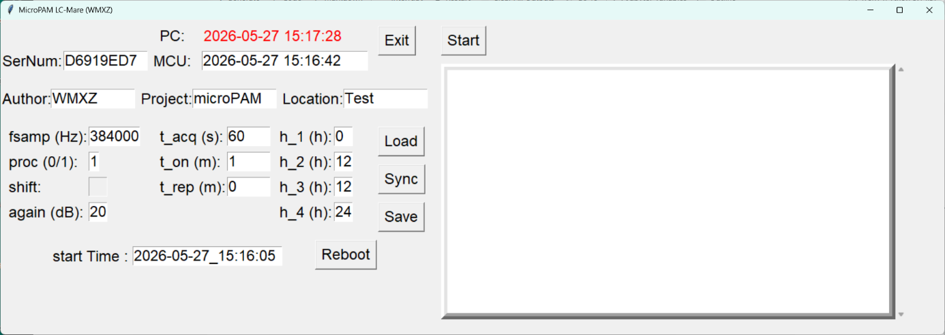
Buttons:
Load: to update fields from device
Sync: to synchronize MCU RTC to PC clock
Save: to write fields back to device. Needed after modifications made on GUI.
Reboot: triggers a reboot of device. Start Time will be considered if at later time.
Exit: exits program
Start: start the acquisition, will become stop button. Messages from device will be shown in window. Use of GUI will initialize start Time to GUI launch time.

